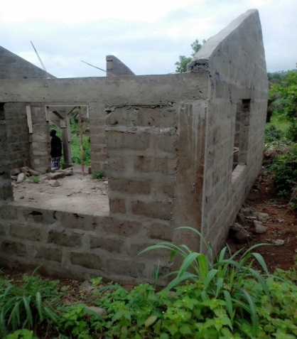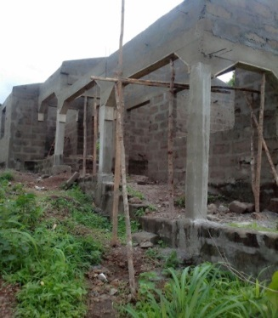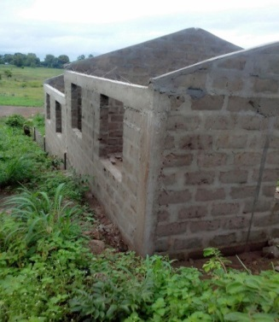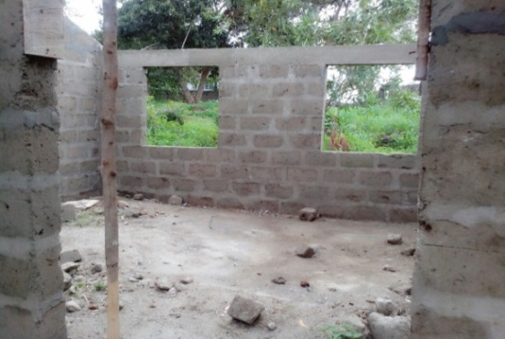

**TOMBO WALKS**

**Beejacks Tombo Foundation**

|  |  |  |  |  |  |
| --- | --- | --- | --- | --- | --- |
| **Name** | **Address** | **Post Code** | **Contact Details** | **Gift Aid** | **Amount** |
|  |  |  |  |  |  |
|  |  |  |  |  |  |
|  |  |  |  |  |  |
|  |  |  |  |  |  |
|  |  |  |  |  |  |
|  |  |  |  |  |  |
|  |  |  |  |  |  |
|  |  |  |  |  |  |
|  |  |  |  |  |  |
|  |  |  |  |  |  |
|  |  |  |  |  |  |
| **Name** | **Address** | **Post Code** | **Contact Details** | **Gift Aid** | **Amount** |
|  |  |  |  |  |  |
|  |  |  |  |  |  |
|  |  |  |  |  |  |
|  |  |  |  |  |  |
|  |  |  |  |  |  |
|  |  |  |  |  |  |
|  |  |  |  |  |  |
|  |  |  |  |  |  |
|  |  |  |  |  |  |
|  |  |  |  |  |  |
|  |  |  |  |  |  |
|  |  |  |  |  |  |
|  |  |  |  |  |  |
|  |  |  |  |  |  |
|  |  |  |  |  |  |
|  |  |  |  |  |  |
|  |  |  |  |  |  |
|  |  |  |  |  |  |
|  |  |  |  |  |  |
|  |  |  |  |  |  |
|  |  |  |  |  |  |
|  |  |  |  |  |  |
|  |  |  |  |  |  |
|  |  |  |  |  |  |
|  |  |  |  |  |  |
|  |  |  |  |  |  |
|  |  |  |  |  |  |
|  |  |  |  |  |  |
|  |  |  |  |  |  |
|  |  |  |  |  |  |
|  |  |  |  |  |  |
|  |  |  |  |  |  |
|  |  |  |  |  |  |
|  |  |  |  |  |  |
|  |  |  |  |  |  |